**Laboratory Eight**



**Javier Jesús Macossay-Hernández**

**EE348L – Electronic Circuits**

**University of Southern California**

**Professor Susan Schober**

**Introduction**

In this laboratory, implementation of hand analysis and HSPICE simulations were done to understand the behavior of Bipolar Junction Transistors (BJTs). Furthermore, the filter was built in class and different tests were done to corroborate our hand calculations and simulation results.

Exercise 1

**Procedure**

The following circuit was built and V2 was adjusted from 0V to 5V while fixing V1 at 0.68V, 0.7V, and 0.72V. Then, measurements where taken of the collector every quarter volt.

**Data**

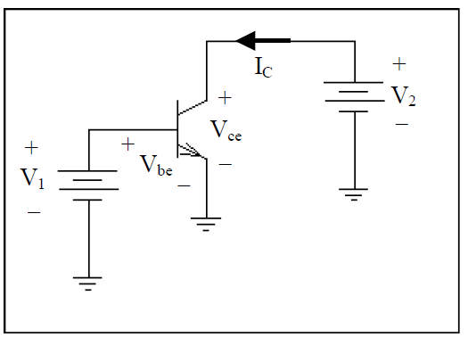

Schematic of the circuit

|  |  |  |  |
| --- | --- | --- | --- |
| V2 | Ic (mA) – V1 = 0.68V | Ic (mA) – V1 = 0.7V | Ic (mA) – V1 = 0.72V |
| 0 | -0.627 | -0.955 | -1.54 |
| 0.25 | 1.39 | 2.38 | 5.39 |
| 0.5 | 1.42 | 2.576 | 5.45 |
| 0.75 | 1.97 | 3.074 | 5.92 |
| 1 | 3.18 | 3.841 | 6.667 |
| 1.25 | 4 | 4.758 | 7.662 |
| 1.5 | 4.55 | 5.81 | 8.842 |
| 1.75 | 5.66 | 6.968 | 10.23 |
| 2 | 6.82 | 8.56 | 11.69 |
| 2.25 | 8.03 | 9.857 | 13.44 |
| 2.5 | 9.349 | 11.221 | 15.29 |
| 2.75 | 10.58 | 12.56 | 17.48 |
| 3 | 11.83 | 14.02 | 19.89 |
| 3.25 | 13.15 | 15.64 | 22.36 |
| 3.5 | 14.44 | 17.436 | 24.88 |
| 3.75 | 15.82 | 19.432 | 27.24 |
| 4 | 17.37 | 22.21 | 29.68 |
| 4.25 | 18.65 | 25.16 | 32.16 |
| 4.5 | 20.41 | 28.44 | 34.56 |
| 4.75 | 22 | 31.01 | 36.28 |
| 5 | 23.61 | 33.56 | 38.45 |

Ic (mA) vs. V2 (V)

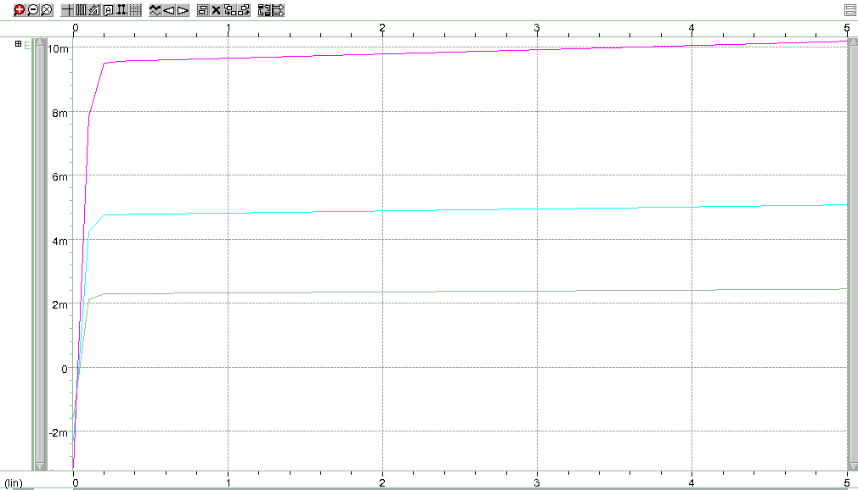

Prelab Plot

**Questions**

The data resembles to the curves I got in the HSpice simulations.

**Discussion**

In both graphs, the transistor reaches the active region at 0.2V and then have small increments in the current, Ic. In addition, the increase in the base voltage gives a result of an increment in the current magnitude. Also, the results from the actual laboratory experiment have slightly smaller current magnitude and the slope is significantly steeper. Two factors influence in these results: 1) the BJT was not working properly compared to the one used in the simulation. 2) There is an output resistance at that terminal resulting in the slope in the linear region.

Exercise 2

**Procedure**

The following circuit was built and Vb and Vc were measured. Then, R3 was adjusted to make Vc equal to 6.5V. Vcc = 10V.

**Data**

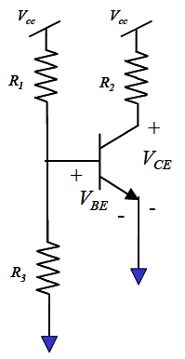

Schematic of the circuit

|  |  |
| --- | --- |
| R2 | 4.92*10^3 |
| R1 | 13.295*10^3 |

Constant Values in the Circuit

|  |  |
| --- | --- |
| R3 | 992 |
| Vc | 3.34 |
| Vb | 0.688 |

Initial Values in the Circuit

|  |  |
| --- | --- |
| R3 | 959 |
| Vc | 6.45 |

Final Values in the Circuit

**Questions**

The BJT operating point is Ic = (10V – 3.34V)/(4.92 kΩ) = 1.35 mA, Vc = 3.34, and Vb = 0.688V. The collector voltage is really sensitive to R3. R3 decreased 33 Ω and the voltage increased 3.11 V.

**Discussion**

Yes, this confirms my answer to the pre-lab exercise 2 because R3 is inversely proportional to Vc. Additionally, R3 is used as a voltage divider and by decreasing it increments the values Vb.

Exercise 3

**Procedure**

The following circuit was built and Vc, Ve, and Vb were measured. Then, R3 was adjusted to make Vc equal to 6.5V. Vcc = 10V. In the prelab, this circuit was designed. As a result, Vc = 5.3V, R3 = 4.7 kΩ, Vb = 1V, R2 = 1.88 kΩ, R4 = 120 Ω, R1 = 42.3 kΩ and the current was 2.5 mA. After building the circuit, we will calculate β.

**Data**

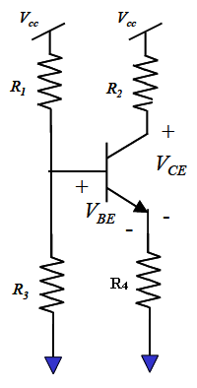

Schematic of the circuit

|  |  |  |
| --- | --- | --- |
|  | **Theory Values** | **Real Values** |
| **R1 (kΩ)** | 42.3 | 42.33 |
| **R2 (kΩ)** | 1.88 | 1.86 |
| **R3 (kΩ)** | 4.7 | 4.696 |
| **R4 (kΩ)** | 0.12 | 0.121 |
| **Vc (V)** | 5.3 | 5.97 |
| **Vb (V)** | 1 | 0.957 |
| **Ve (V)** | 0.3 | 0.263 |

Prelab values and values from the actual circuit

|  |  |  |  |
| --- | --- | --- | --- |
|  | **R (kΩ)** | **I (mA)** | **Vdrop (V)** |
| **R1** | 42.33 | 0.213 | 9.001 |
| **R2** | 1.86 | 2.497 | 4.645 |
| **R3** | 4.97 | 0.201 | 0.999 |
| **R4** | 0.121 | 2.504 | 0.303 |

Resistances and their respective current and voltage drops

**Questions**

Since Vce was off by 14% from the value desired, R3 was changed by a potentiometer and it was adjusted until the desired value was obtained. When R3 was equal to 4.97 kΩ, Vc = 5.3555V, Vb = 0.999V, and Ve = 0.303V. As a result, the collector current is equal to 2.497 mA.

β = Ic/Ib = IR2/(IR1 – IR3) = 208

**Discussion**

Vce was 14% off because considered β to be infinite. Therefore, the circuit design was built using this approximation and it yielded to a 14% error. This method was used, so we could get a range of the values of the resistors. Additionally, β infinite makes us neglect the effect of Ib in the circuit. Additionally, BJTs are not fabricated perfectly. Therefore, the transistor used in the lab will have an influence in our results.

**Conclusion**

The results clearly agree with the objective of the lab that is to learn how BJTs behave. In addition, we use HSpice and WaveView Analyzer to corroborate our hand calculations and our measured values. Important and vital concepts were reinforced as same as the formulas needed to calculated β and how to approach the circuit. Additionally, we learned to make assumptions when designing the circuit, but that we should be conscious about using a potentiometer to adjust the values to the ones required.